Starting Points Hereford
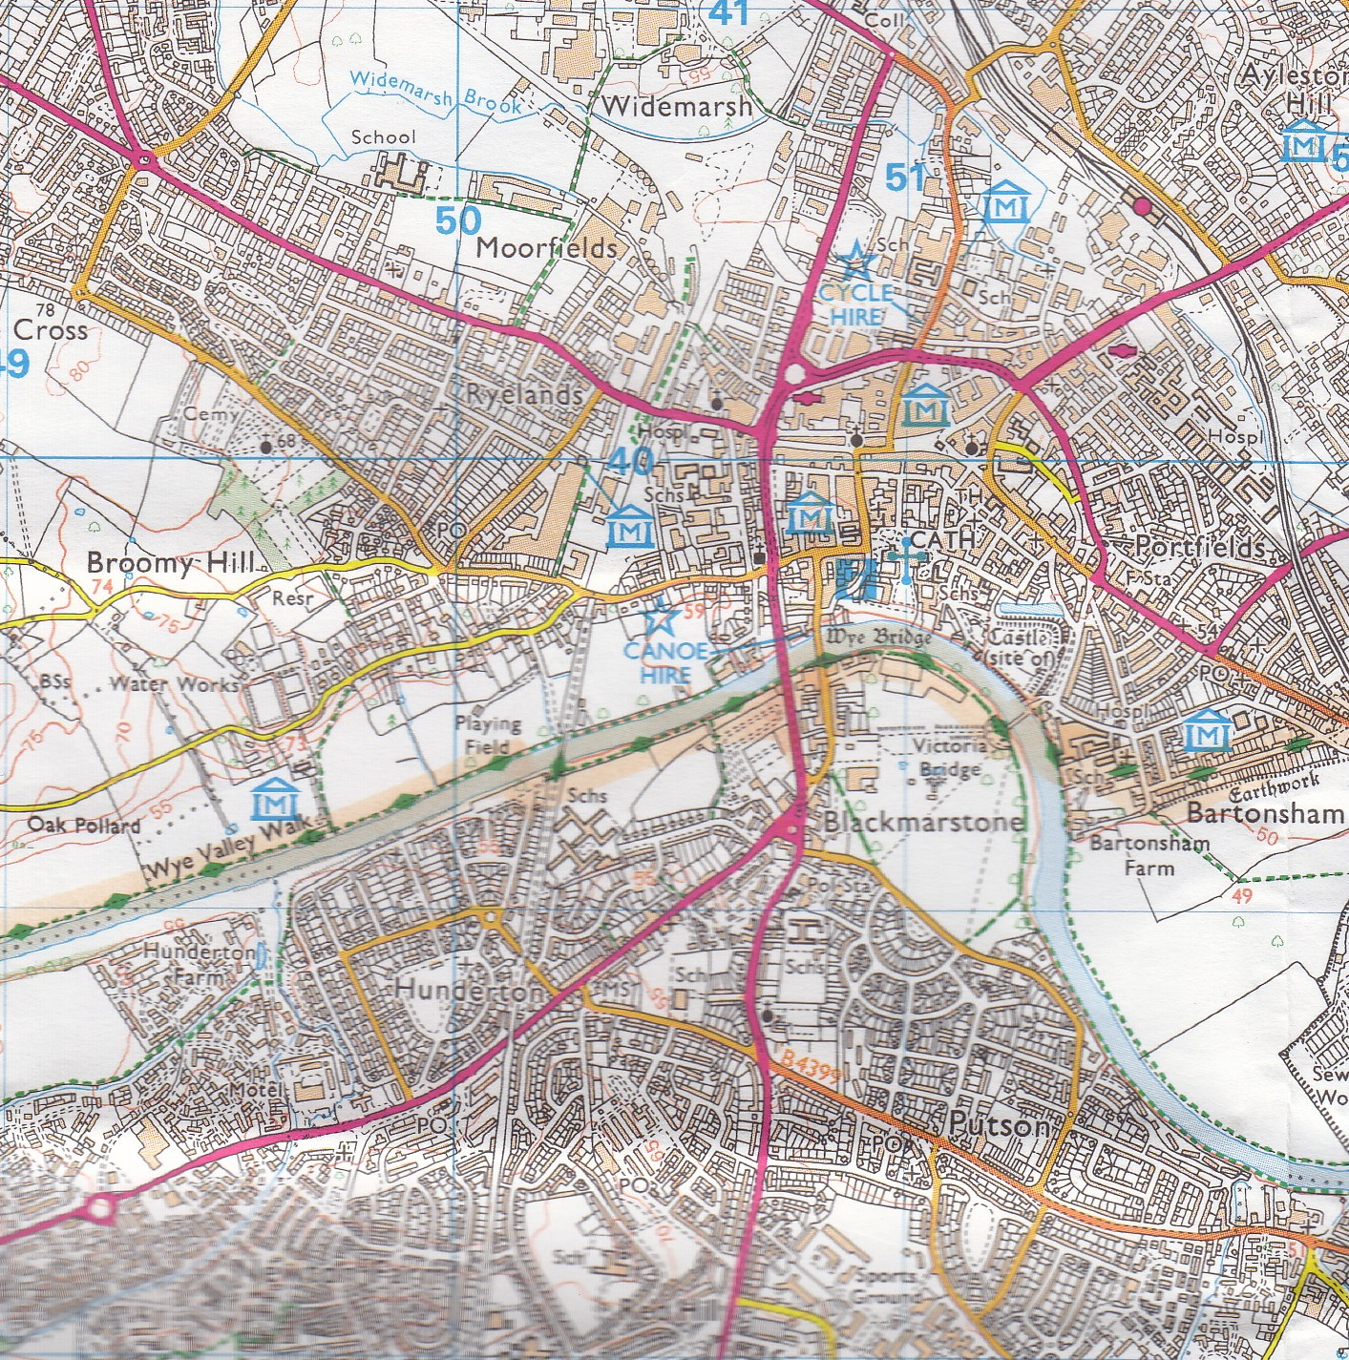

Whitecross Roundabout.
1
1

Fire Station.
2

Asda. Belmont Road.
3

Tesco’s Roundabout
2
4
3

4

